**Name of the College: NIIT R.G.P.G College Meerut **

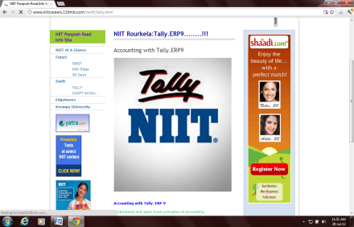 Student Name:________________________________Reg no:________________________

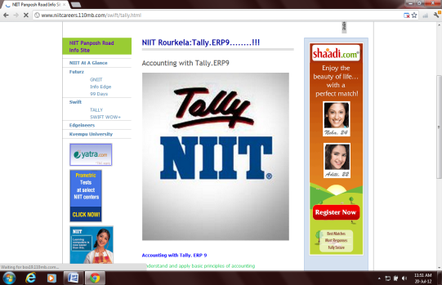 Class:______________Date:_________________Time:30 Min Max Marks: 100 Marks **ADV-** **Set-1**

**QUALIFYING EXAM OF TALLY**

|  |  |  |  |  |  |  |  |
| --- | --- | --- | --- | --- | --- | --- | --- |
| SN | QUESTION_STATEMENT | ANS_A | ANS_B | ANS_C | ANS_D | ANS_E | Ans |
| 1 | In Tally we can maintain | Inventory only | Accounts only | Inventory with account | All of the above | Both B & C | e |
| 2 | Net Debit / Credit Balances for Reporting option of a Group | does not allow any credit balance | does not allow any debit balance | shows the accumulated balance | None of these |  | c |
| 3 | Is it possible to pay different salary to an individual who fall under the same group where salary structure are same | a) Yes | b) No |  |  |  | a |
| 4 | Tally by default provides | 5 ledgers | 4 ledgers | 2 ledgers | no ledgers | None of the above | c |
| 5 | To pass reversing journal entry press | F10 | Ctrl + F10 | Alt + F10 | F9 | None of these | a |
| 6 | Through which configuration we can activate Dr / Cr instead of To / By ? | F11 | F12 | Alt+F3 | None |  | b |
| 7 | Bank OCC Accounts is the alias of | Bank Accounts group | Bank Overdraft group | Both | None of these |  | b |
| 8 | In Tally Simple and Compound Interest can be charged. | True | False |  |  |  | a |
| 9 | F12 - Key is also known as | Configuration window | Company Features window | Company Properties window |  |  | a |
| 10 | If a Company has splitted on 1-Sep-2004 then what will happen with the Company? | Company data till 31-Aug-2004 will be deleted | Company data will be shifted to a new Company | Actual Company will be divided into two parts. | Actual Company will remain unchanged and other two companies will be generated. | None of these | d |
| 11 | Bad Debts are recorded through | Contra mode | Journal mode | Receipt mode | Payment mode | None of these | B |
| 12 | Is it mendatory to select the type of organization at the time of service tax configuration | a) Yes | b) No |  |  |  | a |
| 13 | Tally can warn on negative balance of Cash. | True | False |  |  |  | a |
| 14 | To invoke Memorandum voucher press | F10 | Alt + F10 | Ctrl + F10 | None of these |  | c |
| 15 | To switch from Profit & Loss a / c to Balance Sheet we will use | F10 | alt + 10 | F11 | Ctrl + F12 |  | a |
| 16 | At the time of ledger creation the shortcut to create online Group / Subgroup is | Insert key | Ctrl + C | Alt + C | Ctrl + Enter |  | c |
| 17 | Is it mendatory to select the service tax categories at the time of service tax ledger creation | a) Yes | b) No |  |  |  | a |
| 18 | To link reciept note with suppliers Invoice we use | Delivery Note | Debit Note | Credit Note | Tracking No | None of the above | d |
| 19 | Can we Create two Company having same name ? | yes | no |  |  |  | a |
| 20 | To use the expiry date for stock item turn on the option | Maintain batch wise details | Set expiry date for batches | Manufacturing date | Both A & B |  | d |
| 21 | In purchase bill we can given Tracking Number | TRUE | FALSE |  |  |  | b |
| 22 | Input tax credit will be available when the goods are purchased from | Register Dealer | Wholeseller | Retailer | Unregister dealer |  | a |
| 23 | Started Business with cash Rs 100000. We will pass this entry using | Contra mode | Payment mode | Receipt mode | None of these |  | c |
| 24 | To show VAT classification report we use | F12 at VAT Computation report | F9 at VAT computation report | F5 at VAT computation report | F7at VAT computation report | None of the above | a |
| 25 | Can we zoom any reports in tally ? | yes | no |  |  |  | a |
| 26 | Debit Note means Sales Return | Yes | No |  |  |  | b |
| 27 | For Payroll Auto Fill You can Press | a) Ctrl + F7 | b) Alt + F7 | c) Either (a) or(b) | d) none of These |  | a |
| 28 | Stock categories can be maintained in Tally | True | FALSE |  |  |  | a |
| 29 | Full form of BOM is | Bills of Month | Bill of Material | Batch of Material | None of these |  | b |
| 30 | During Voucher Entry in the amount column ALT+C stands for | Online creation of Ledgers | Online Calculation | Online Group Creation | None |  | b |
| 31 | The shortcut to Delete a Company is | Alt + Delete | Shift + Delete | Ctrl + Delete | Alt + D | Alt + X | d |
| 32 | How to switch between opened Companies | Alt + F3 | F1 | F3 | F2 | Ctrl + F3 | c |
| 33 | Cash ledger can be allowed in journal mode | true | FALSE |  |  |  | a |
| 34 | Manufacturing Journal is a | Document Class | Voucher Class | Manufacturing Class | Sales Class |  | b |
| 35 | Challan is prepared before | order | quotation | invoice | return |  | c |
| 36 | We can not keep e-mail address in Company Creation Screen | True | False |  |  |  | b |
| 37 | Is it possible to delete the main location ? | yes | no |  |  |  | b |
| 38 | Vat report consists of | Input Vat on trading goods | Output Vat on trading goods | CST at the time of sales for trading goods | Input vat on purchase of capital goods | All of the above | e |
| 39 | To view current balance of ledger during voucher entry turn on the option | Show Ledger Balances from F11 | Show Ledger Current Balances from F12 | Display Current Balance from F11 | None of these |  | b |
| 40 | The Option - Allow Component List Datails (BOM) - is used for | Purchase | Sales | Manufacturing | Voucher Class |  | c |
| 41 | Report of memorandum vouchers can be viewed through | Exception reports | Statutory master | Stock summary | none of these |  | a |
| 42 | Is it possible to see the opening balance in trial balance | Yes | No |  |  |  | a |
| 43 | Depreciation ledger falls under | Indirect Incomes | Fixed Assets | Indirect Expenses | Direct Incomes |  | c |
| 44 | Income Tax number of the Company will appear in which report? | Balance Sheet | Profit and Loss | Account Confirmation Statement | Reminder Letter |  | c |
| 45 | Shortcut for TDS deduction in Tally is | Alt+C | Alt+S | Alt+T | Ctrl+T | Ctrl+K | b |
| 46 | Keeping a copy of data in other media is termed as | Tally Vault | Tally Audit | Restore | Backup | All of the above | d |
| 47 | "Is it required to create the ledger named "" VAT refundable""" | a) Yes | b) No | c) Yes depends on situation | d) All of the above |  | c |
| 48 | Within Company alteration window we can define | an Administrator | a User | Name of the Proprietor | All of these | None of these | a |
| 49 | Is it necessary to create at least one item for maintaining price List | True | False |  |  |  | a |
| 50 | User can print Confirmation of Statement of any ledger from Tally 9.0 | True | False |  |  |  | a |